# 2. ReactJs-HOL

Code:

About.js

import React from 'react';

function About() {

  return (

    <div>

      <h2>Welcome to the About page of the Student Management Portal</h2>

    </div>

  );

};

export default About;

Contact.js

import React from 'react';

function Contact() {

  return (

    <div>

      <h2>Welcome to the Contact page of the Student Management Portal</h2>

    </div>

  );

};

export default Contact;

Home.js:

import React from 'react';

function Home() {

  return (

    <div>

      <h2>Welcome to the Home page of Student Management Portal</h2>

    </div>

  );

};

export default Home;

App.js:

import React from 'react';

import Home from './Home';

import About from './About';

import Contact from './Contact';

function App() {

  return (

    <div>

      <Home />

      <About />

      <Contact />

    </div>

  );

}

export default App;

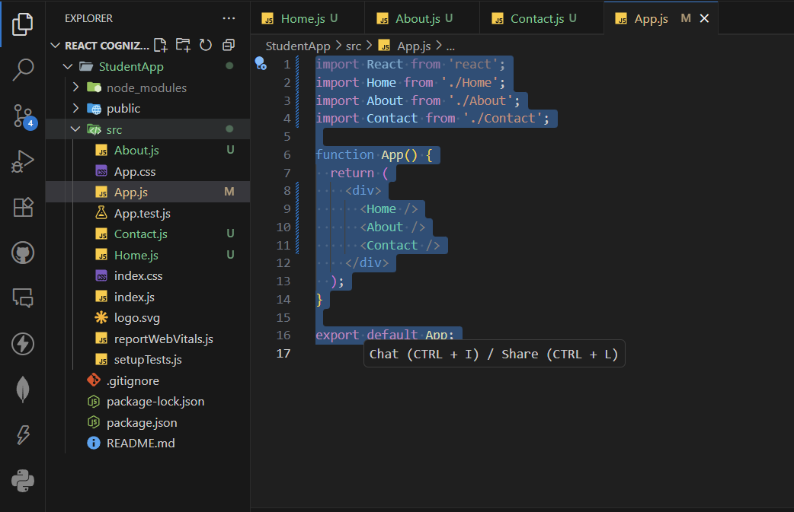File Structure:

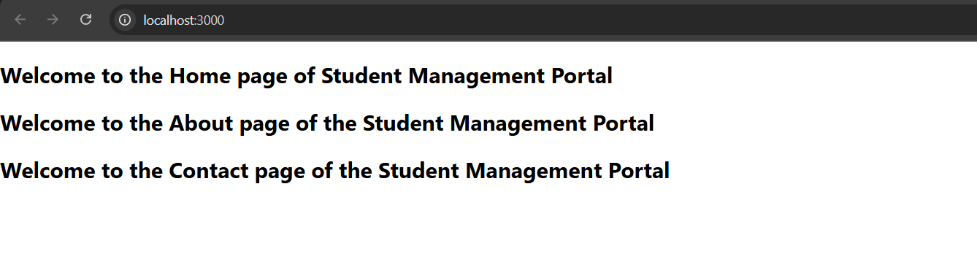Output: